**What is Asp .Net Core?**

ASP.NET Core consists of a platform for processing HTTP requests, a series of principal frameworks for creating applications, and secondary utility frameworks that provide supporting features.

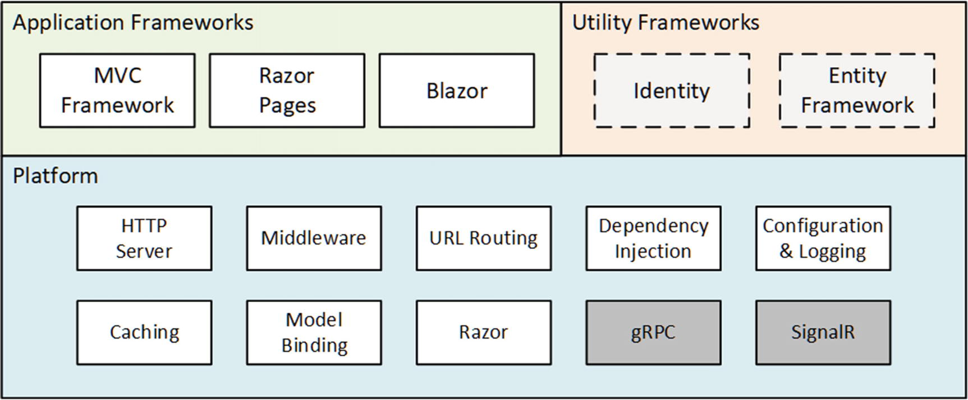

**Understanding the MVC Framework**

MVC stands for Model-View-Controller, which is a design pattern that describes the shape of an application. The MVC pattern emphasizes separation of concerns, where areas of functionality are defined independently.

**MVC versus Singe-page Applications**

The MVC Framework remains an important part of ASP.NET Core, but the way it is commonly used has changed with the rise of single-page applications (SPAs). The shift to SPAs means that the clean separation that the MVC Framework was originally intended for is not as important, and the emphasis placed on following the MVC pattern is no longer essential.

**Single-page Applications**

In an SPA, the browser makes a single HTTP request and receives an HTML document that delivers a rich client, typically written in a JavaScript client such as Angular or React.

**How to use Design Patterns**

My advice is to use patterns freely, adapt them as necessary, and ignore zealots who confuse patterns with commandments.

**Understanding Razor-pages**

One drawback of the MVC Framework is that it can require a lot of preparatory work before an application can start producing content. Razor Pages takes the development ethos of Web Pages and implements it using the platform features originally developed for the MVC Framework. Code and content are mixed to form self-contained pages;

**Understanding Blazor**

The rise of JavaScript client-side frameworks can be a barrier for C# developers, who must learn a different—and somewhat idiosyncratic—programming language. Blazor attempts to bridge this gap by allowing C# to be used to write client-side applications.

**Blazor Server**

Blazor Server is a stable and supported part of ASP.NET Core, and it works by using a persistent HTTP connection to the ASP.NET Core server, where the application’s C# code is executed.

**Blazor WebAssembly**

Blazor WebAssembly is an experimental release that goes one step further and executes the application’s C# code in the browser.

**What is a Client-side Framework**

The client-side framework is usually a JavaScript library and runs in a Web browser, such as React, Angular and Vue.

**Understanding Entity Framework**

Two frameworks are closely associated with ASP.NET Core but are not used directly to generate HTML content or data. Entity Framework Core is Microsoft’s object-relational mapping (ORM) framework, which represents data stored in a relational database as .NET objects.

**Understanding Asp.Net Core Identity**

ASP.NET Core Identity is Microsoft’s authentication and authorization framework, and it is used to validate user credentials in ASP.NET Core applications and restrict access to application features.

**Asp .Net Core Platfrom**

The ASP.NET Core platform contains the low-level features required to receive and process HTTP requests and create responses. There is an integrated HTTP server, a system of middleware components to handle requests, and core features that the application frameworks depend on, such as URL routing and the Razor view engine.